AI Assisted Coding Lab - 2
Ch srinidh rao
2303A52398
Batch-44
Task-1
Zero-Shot Prompting (Palindrome Number Program) Prompt:
Write a Python function that checks whether a given integer is a palindrome. The function should return True if the number is a palindrome and False otherwise.Do not provide any examples.
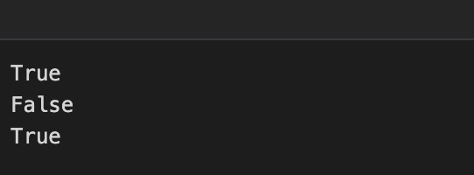
Code:
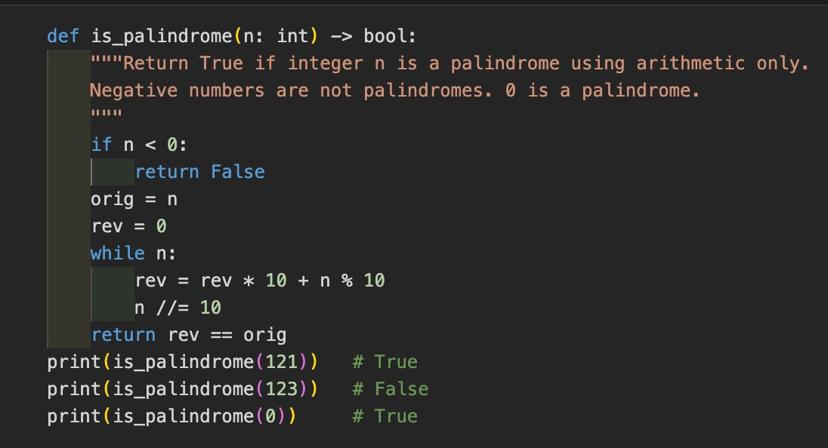
Output:
One-Shot Prompting (Factorial Calculation) Prompt:
Write a Python function to calculate the factorial of a given number. Example:
Input: 5
Output: 120 Code:
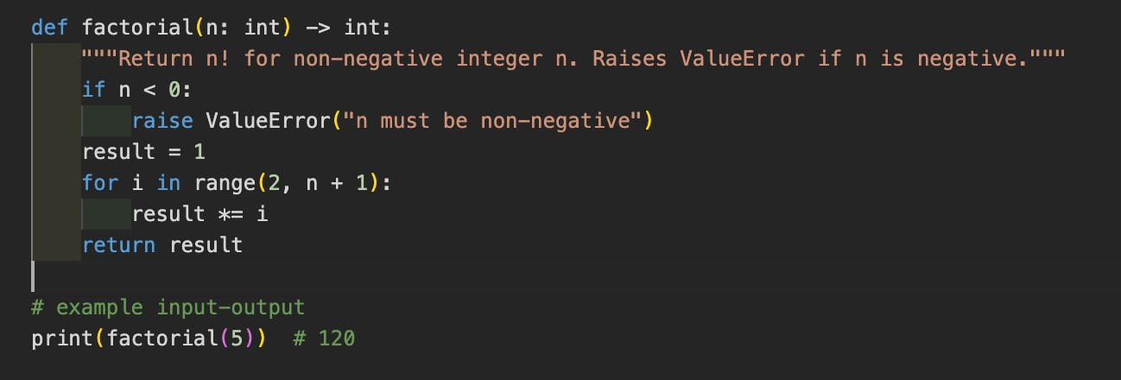
Output:
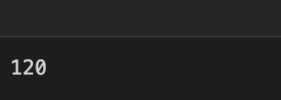
Few-Shot Prompting (Armstrong Number Check)
Prompt:
Write a Python function to check whether a number is an Armstrong number. Code:
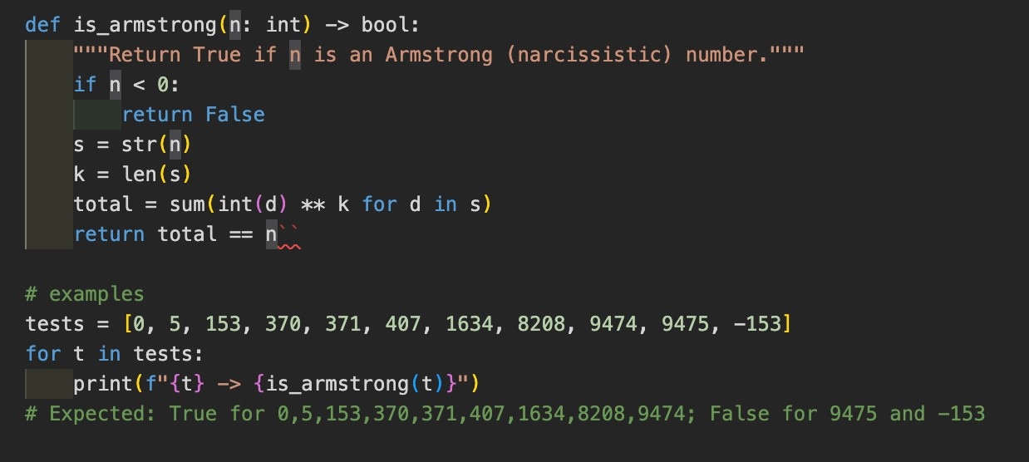
Output:
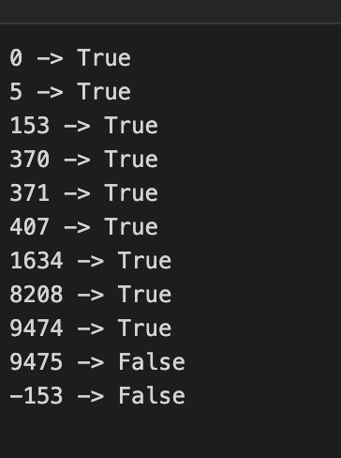
Context-Managed Prompting (Optimized Number Classification)
Prompt:
You are an AI coding assistant.
Generate an optimized Python program that classifies a number as:
- Prime
- Composite
- Neither Prime nor Composite Constraints:
- Validate the input properly
- Handle edge cases like 0, 1, and negative numbers
- Use efficient logic for prime checking
- Return clear output messages Code:
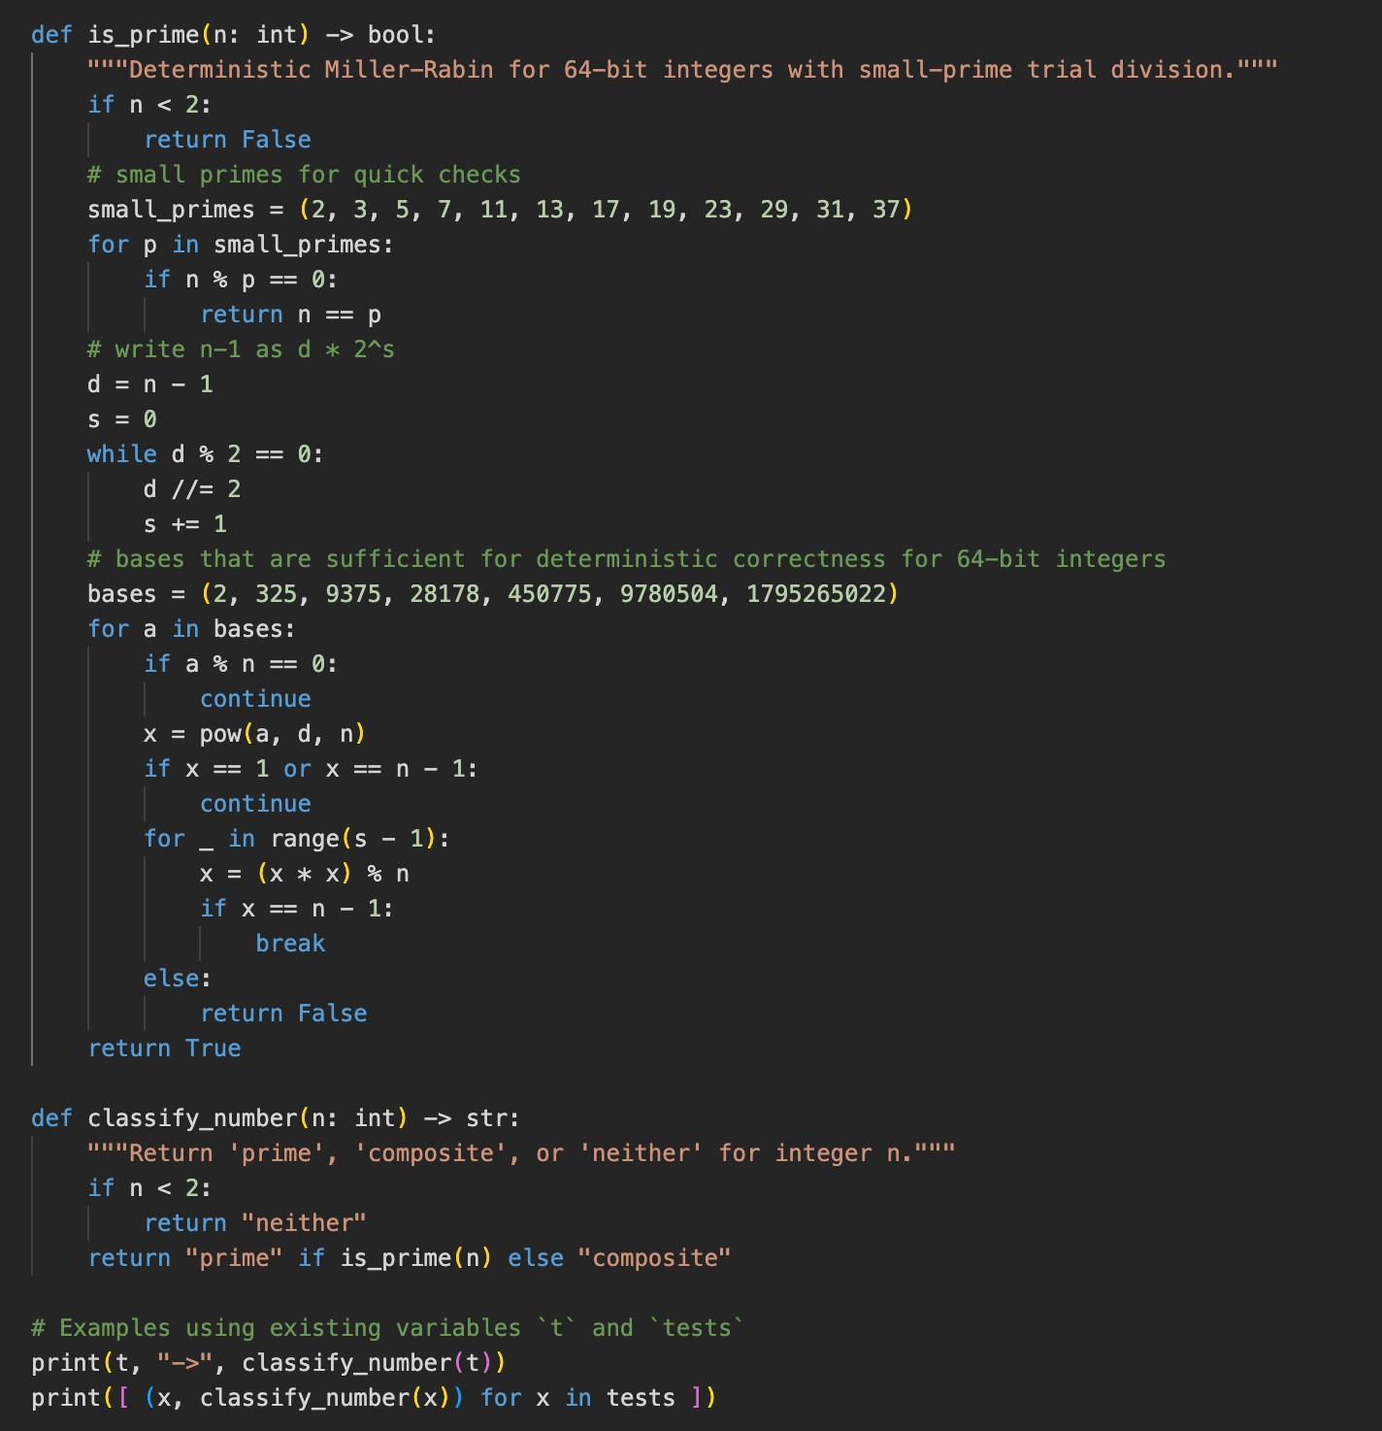

Output:
Task-5:
Zero-Shot Prompting (Perfect Number Check) Prompt:
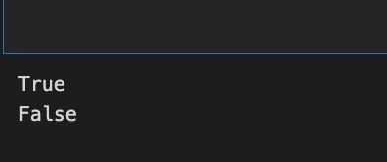
Write a Python function that checks whether a given number is a perfect number.The function should return True if it is a perfect number and False otherwise. Do not include any examples. Code:
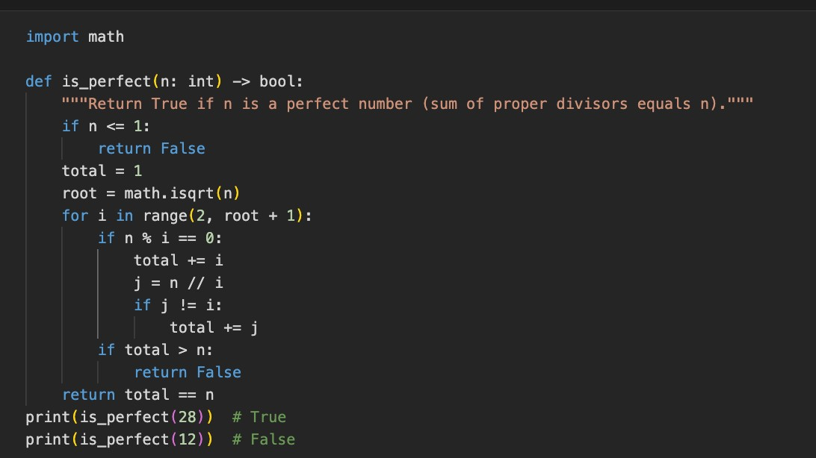
Output:
Task-6
Few-Shot Prompting (Even or Odd Classification with Validation) Prompt:
Write a Python program to determine whether a number is even or odd.
Include proper input validation.
Code:
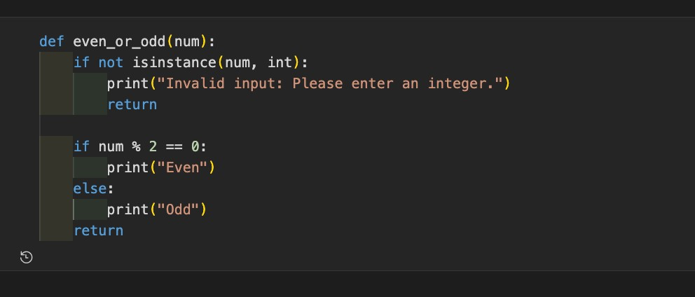
Output:
